a)

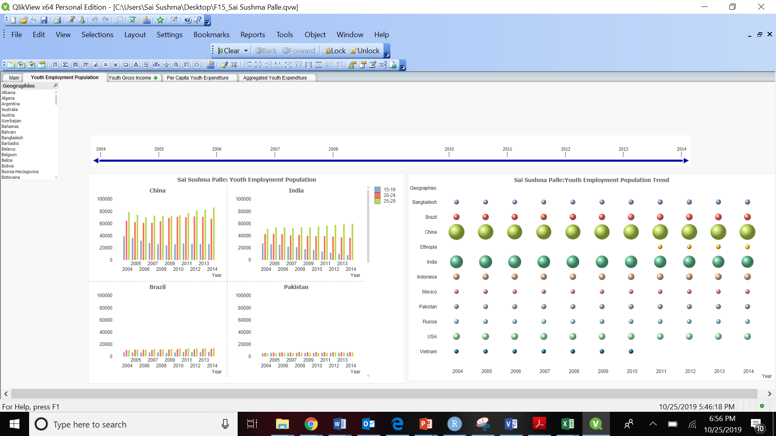

b)

China has highest youth Employment Population.

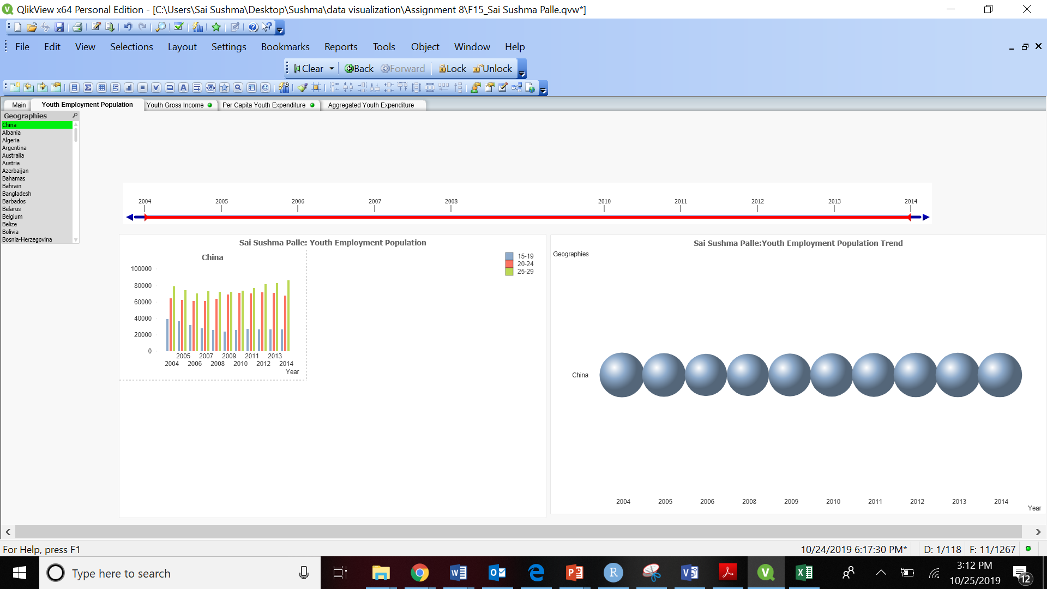

c)

Very few of the youth employment population group belongs to 15-19 age group. Most of the youth employment population belongs to 25-29 age group category.

For Pakistan, the youth Employment population between age groups 20-24 is highest in all years between 2005 to 2014.

Trend for Pakistan between these Age groups:

**Age group (15-19):**

Initially it went high from 2005 to 2006 and dropped down through 2014.

**Age group (20-24):**

Initially it was lower in 2005 and then went on increasing until it reached till 2014.

**Age group (25-29):**

Initially it was lower in 2005 to 2006 and then remained constant for a while, after which it increased in 2014.

d)

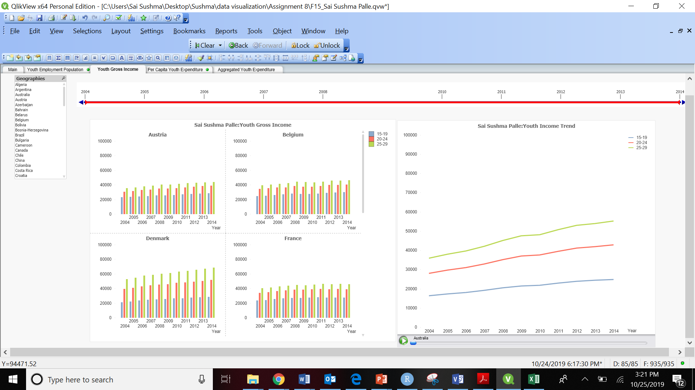

e)

There was a dip in the year 2009 across all categories.

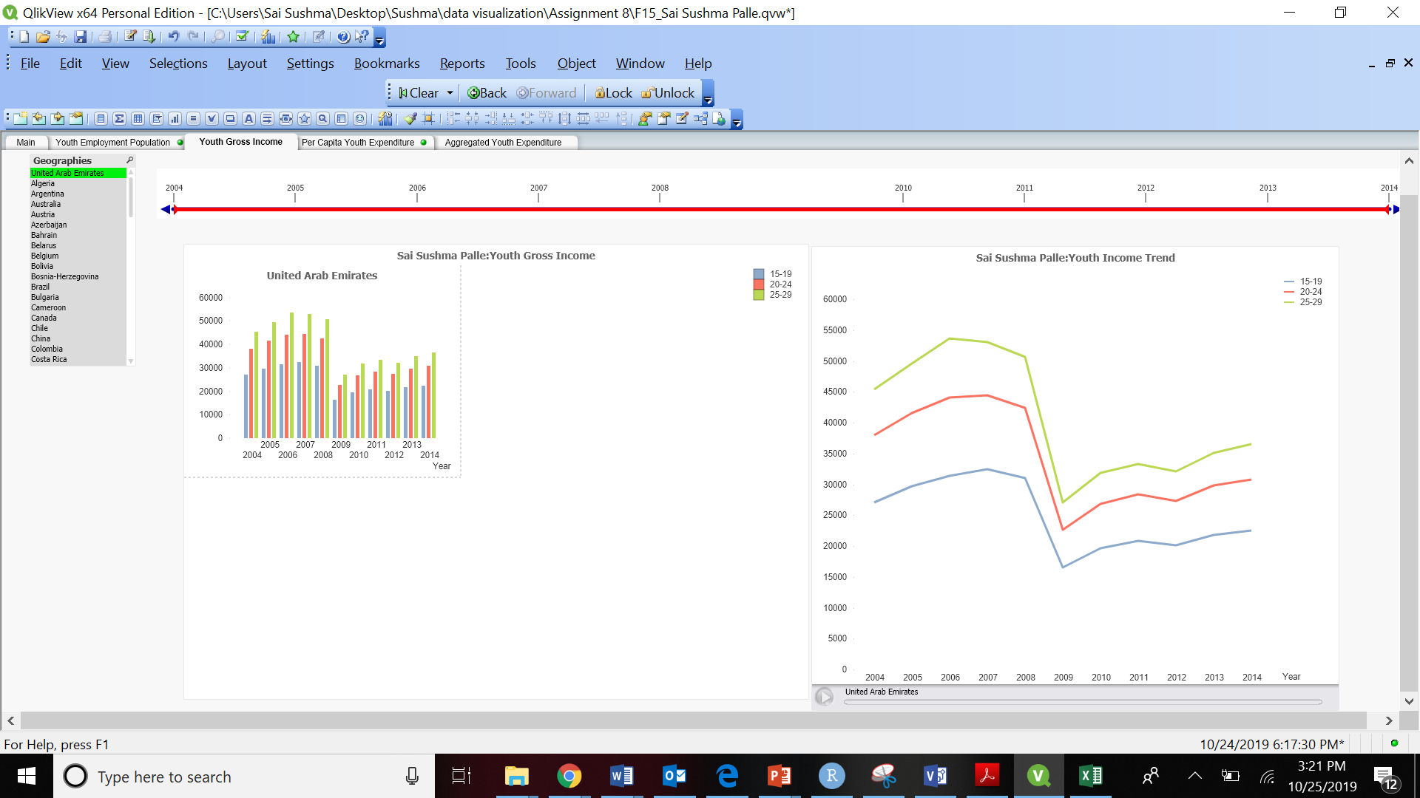

f)

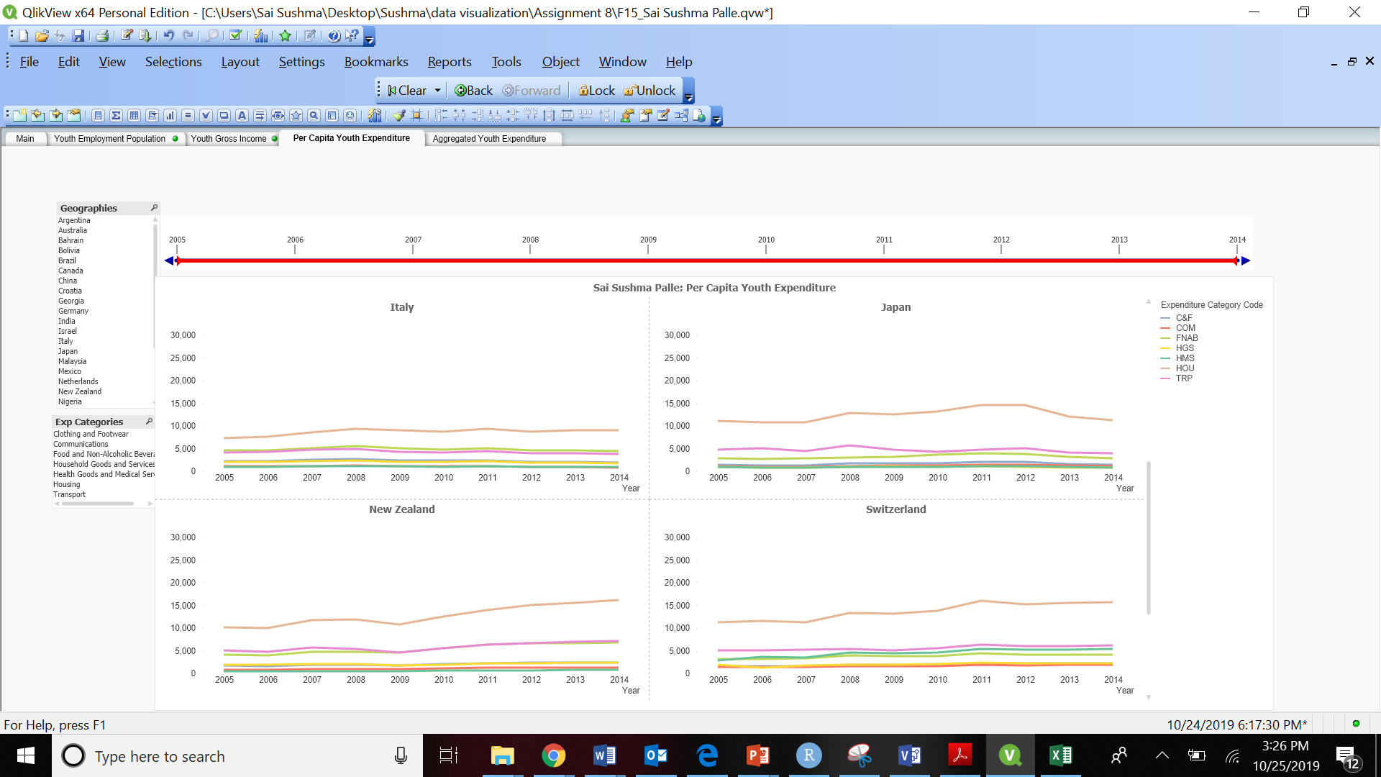

g)

The youth Spend more on **Housing** Category

h)

The commodity the youth in Switzerland spends the most in the year 2007 is on Housing (HOU).

i)

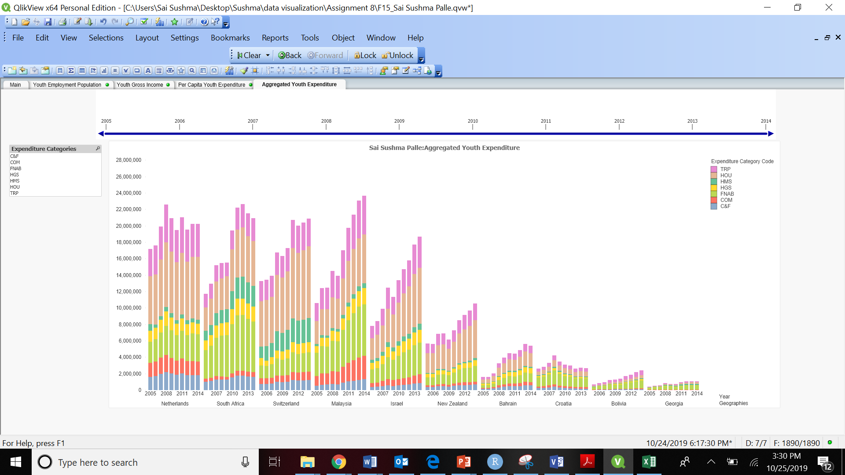

j)

The youth spend on Housing the most in Switzerland is 2011.

k)

The Sudden dip in the youth expenditure in Ukraine is 2009, 2014